Gear Transmission Fault Modeling in Servo Based Driveline with Compensation Algorithm
First A. Author1, Membership, Second B. Author2, Membership,
and Third C. Author3, Membership
Abstract— This paper present gear transmission dynamics, fault modeling and fault compensation algorithm in the industrial servo drivelines. Firstly, a proper gear system dynamics, mathematical model and basic control structure are defined. After that, fault model and mathematical analysis for compensation algorithm are derived for tooth abrasion or fracture fault scenario. Secondly, a compensation algorithm is developed with using derived fault model. Developed algorithm is embedded to the control structure and compensation algorithm is set for preventing the damage on the driveline and unusual peaks on the speed and torque. System is simulated on Matlab/Simulink environment and tested on the 400W industrial servo motor driven setup. The results show that, developed fault model and compensation algorithm works as a protective structure against such a serious faults.

Index Terms—Gear Fault Diagnosis, Gear Fault Modeling, Fault Compensation Algorithm, Servo Motion Control

INTRODUCTION
A
GEAR transmission is the essential part of the servo motor based driveline systems. Generally, the main aim of the gear transmission usage is reducer or booster the speed, also changing the direction (or axis) of the motion. These gear mechanisms can be used alone to transmit motion or in combination with another drive-train.

Gear Dynamics and Control Structure
A proper gear system transmits the motion via its tooth structure with principle of the thrust with friction. The basic dynamic principle is based on Newton’s second law $(Force=Mass×acceleration)$ as shown in (1).

$\sum{T}=Jα$ (1)

Where, $T$ is torque, $α$ is angular acceleration, $J$ is the mass moment of inertia for the rotational element. After defining torque and inertia relation, another critical definition of the gear system is gear ratio $N_{GR}$ in (2).

$N_{GR}=\frac{w_{m}}{w_{l}}=\frac{r_{l} (or n_{l})}{r_{m} (or n_{m})}$ (2)

Where, $w_{m}$ and$w_{l}$ are angular speeds, $r_{m}$ and $r_{l}$ are radii and $n_{m}$ and $n_{l}$ are the tooth number of motor shaft gear and load shaft gear respectively. The mentioned proper gear system is given in Fig. 1.

Fig. 1. A proper servo motor – gear – load system

The dynamic relation of the proper gear system can be defined via tangential speed $V_{tangential}$ at the connection point of two gears in (3). If the gear system provides (3), we can define power for both motor and load sides in (4).

$V_{tangential}=w_{m}r_{m}=w_{l}r_{l}$ (3)
$P_{m\left(or l\right)}=T_{m \left(or l\right)}w_{m \left(or l\right)}, \left(η= \frac{P_{l}}{P_{m}} ×100\right)$ (4)

Where, $P_{m\left(or l\right)}$refers to power and $T_{m \left(or l\right)}$ refers to torques of motor (or load) side respectively. The efficiency $η$ of the gear transmission is also defined in (4). In the case of defining the reflected torque and inertia from load side to motor side, we can define equality relation in terms of motor and load rotation angles $θ_{m}$ and $θ_{l}$ respectively in (5).

$r_{l}θ_{l}=r_{m}θ_{m} \left(where {\dot{θ}}_{m}=w_{m}, { \ddot{θ}}_{m}=α\right)$ (5)

If we rewrite the (1) in terms of ${ \ddot{θ}}_{l}$ for load in (6), we can obtain the also torque-inertia relation between load and motor side with using (2).

$T_{l}=J_{l}{\ddot{θ}}_{l}={ηN}_{GR}T_{m}$ (6)

After definition the basic equality relations, we can differentiate (5) both side twice in (8) and solve the equation with using (2, 4, 6). The reflected inertia and torque can be obtained in (9-12).

$r_{l}{\ddot{θ}}_{l}=r_{m}{\ddot{θ}}_{m}$ (8)
${ηN}_{GR}T_{m}=J_{l}\frac{1}{N_{GB}}{\ddot{θ}}_{m}→T_{m}=J_{l}\frac{1}{η}\frac{1}{N_{GR}^{2}}{\ddot{θ}}_{m}=J_{ref}{\ddot{θ}}_{m}$ (9)
$J_{ref}=\frac{1}{η} \frac{J_{l}}{N_{GR}^{2}}$ (10)
$T_{m}=\frac{1}{η}\frac{w_{l}}{w_{m}}T_{l}$ (11)
$T_{ref}=\frac{1}{η}\frac{T_{l}}{N_{GR}}$ (12)

Transmission of the motion via gear system is effected by also friction $(T_{f})$, viscous damping $(d)$ and stiffness ($k)$. Friction occurs both motor and load sides and can be modeled as Coulomb friction. Viscous damping is valid for motor side and gears separately. Stiffness can be defined for gears (also it represents the stiffness from shafts). When these parameters are combined for motion equation for a proper gear system (Fig. 1), dynamic motion equations (13, 14) are obtained.

$J_{m}{\ddot{θ}}_{m}+d_{m}{\dot{θ}}_{m}+k\left(θ_{m}-θ_{l}\right)+d_{G}\left({\dot{θ}}_{m}-{\dot{θ}}_{l}\right)+T_{fm}=T_{in}$(13)

$J_{l}{\ddot{θ}}_{l}+d_{l}{\dot{θ}}_{l}+k\left(θ_{l}-θ_{m}\right)+d_{G}\left({\dot{θ}}_{l}-{\dot{θ}}_{m}\right)+T_{fl}=0$ (14)

Fault Scenario and Modeling

Fault Scenario
Gear systems are widely used in servo transmissions with purposes of speed or torque reducer/amplifier or position setting. Such gear systems transfers the motion by friction (teeth) from actuator (servo motor) side to load side. The main problem is, as these gear systems operate, they wear or break mechanically. Or it works with gaps (backlash phenomena) between teeth due to assembly errors. These error conditions cause the teeth to slip over each other from time to time. These errors:
- effect main motion profile from motor to load
- create unexpected torque and speed peaks
- reflected torque and inertia are out of order
- increase steady state errors, feedbacks are fails so this effects the controller
- may lock the gears (broken tooth)

Fig. 2. Tooth fault gear system

When the fault occurs on the gear tooth, the equality relation between speed of the motor shaft and load shaft (3) turns to inequality as shown in (15). Mechanical contact and motion transmission between two gears is distorted.

$V_{tangential}≠ w_{m}r_{m}>w_{l}r_{l}$ (15)

Fault Modeling
In the servo system we have speed/position (encoder) sensor at the motor side. If the speed of the motor shaft creates unusual peaks, we can determine the fault condition. Detection of the speed peak due to fault can be determined by following procedure. Motor shaft speed is tracked by software during maintenance operation time as end of the day or daily operation. If the fault occurs, speed of the motor $w_{m}$ creates a peak (depends on the $K_{p}$ coefficient of the PID controller of the speed) and the position angle $θ_{m}$ increases during fault time as shown in Fig. 3. So the time derivative of the speed (angular acceleration $α$) increases. The main issue is how can we define the sudden change is because of fault or speed command change. To make this distinction, we need to know the speed controller behavior. In a system whose speed is controlled with a PID controller, the speed change is smoother (depends on the $K_{p}$ coefficient of the speed PID controller) with a torque increasing, while the speed changes are robust in case of a fault and torque goes to zero. In this case, if the speed is increased by a reference command, the speed changes with torque need. This means that $i_{q}$ current increases. If the speed changes in case of error, the speed increases but the torque goes to zero. This means that $i_{q}$ current decreases to zero.

Fig. 3. Generic speed - time and rotation angle - time graphs at the fault condition.
For this fault condition, we can create a β indicator which defines the inequality between motor shaft gear speed and load shaft gear speed in (15). At the beginning of the fault β is defined as 1 or 0. β=1, defines has a gear fault, β=0 means system has no gear fault.
After creating β indicator, we can redefine new inequality with unit step $u\left(t\right)$ and dirac delta $δ\left(t\right)$ functions. In this case we can redefine the inequality for fault condition with a coefficient term in (16).

$\left[u\left(t\right)+\left(β×δ\left(t\right)\right)\right] w_{m}r_{m}>w_{l}r_{l}$ (16)

The equations of the motion (13,14) turns into (17,18) because the stiffness $k$ and damping $d_{G}$ of gear turn to zero via the contact loss.

$J_{m}{\ddot{θ}}_{m}+d_{m}{\dot{θ}}_{m}+T_{fm}=T_{in}$ (17)
$J_{l}{\ddot{θ}}_{l}+d_{l}{\dot{θ}}_{l}+T_{fl}=0$ (18)
One of the important characteristic of this type fault occurs periodically. The period of the fault is relative with revolution of the gear and duration of the fault is relative with the angle swept by the faulty teeth. In addition, during starting or when the speed of the load shaft is low, the speed peaks will be higher as there will be more slip in the faulty teeth. As the load shaft accelerates thanks to faultless teeth, fault peaks due to faulty teeth will decrease.

Compensation Algorithm
The main idea

Frequency Domain Analysis Based Techniques
The main works of frequency analysis techniques concentrate around Fourier based analysis. In Fourier transformation based techniques, detection system contains two main parts as signal analyzer in frequency domain and filter. This technique needs excessive computing ability (high process DSP). The work flow of this technique contains three basic processes. The first one is collecting the position, speed, current/voltage or torque error data (whichever system is controlled) and these data is saved in a memory element. After that Fourier analysis of collected data is done. At this step classical FFT or DFT computation takes much more time in real time systems. Overcome this challenge, designers determine a resolution for FFT computing according to overall servo system needs. For this purpose, shifted DFT (SDFT) (DFT computing is done when the frequency window is shifted with fixed length) or DWT techniques are in use. Similar approach is used in sweep frequency response analysis (SFRA). In this approach, plant (servo motor and load) is excited by sine wave with consecutive frequency intervals (generally, 5-10 Hz increment is selected and plant is excited after that, results are evaluates in frequency domain with DFT analysis) [A Friction Model-Based Frequency Response Analysis for Frictional Servo Systems Yoshihiro Maeda]. Another technique in same manner is obtaining transfer function (Empirical transfer function estimate, ETFE) of the plant in frequency domain with using DFT. After that processed data can be grouped with using average based methods for data compression (for creating a kind of resolution) or impulse responses can be evaluated (like SFRA). The main logic is decrease the computing time with decreasing the detection frequency resolution of system (2048 point data with Advantech 610H industrial control computer takes 3ms for traditional DFT, 0.1ms for SDFT) [jian kang online detection and suppression]. The second step is, collected and transformed data are sorted (or grouped) with respect to amplitude or center frequency. In this stage, it is known that motor and load controller variables (position speed, current/voltage, torque) are oscillating at resonance frequency. So, in sorted data, the most dominant frequency (or the biggest amplitude) refers to resonance frequency of the system and other ones are vibrations or frictions sourced. The last step is filtering the significant frequencies with side lobes. The coefficients of filter (According to specifications, system has one or more than one filter action such as notch with multi channel, low-pass, high-pass, band-pass) are set. After activating the filtering, disturbance of the system eliminated and controller reference signals are purified. Fig. 7 shows that generic block diagram and FFT analyzer with DSP block (encircled) where detection steps run. Also, a filter block is complement of the detection system.

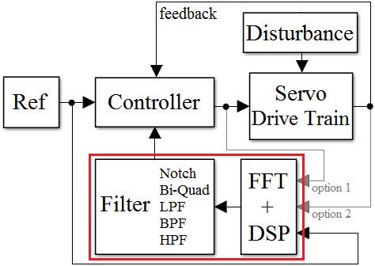

Fig. 7. FFT based disturbance detection system generic block diagram.

Model Based Estimator/Observer/Predictor
The main aim for this technique is to calculate the system parameters or control variables with using linear or nonlinear mathematical model of the plant (motor and load) in time or frequency domain. For this purpose, servo system dynamic behavior must be modeled and executed. Estimator, observer or predictor uses measured data from physical plant and model data and evaluates with statistical methods and system specific calculations. The basic difference between estimators and predictors is feature of produced data. Estimators creates the output data with respect to created trajectory from background information (which is called in models as regression vector), on the other hand predictors creates data that may contain limited randomness and background data. In observers, the operation is based on data or error tracking or comparison of model data and real data. Generally observers work with an estimator or predictor block (i.e. Kalman filter). In servo system dynamics, estimators are heavily used because most of the servo systems are used in industrial applications with limited motion profiles. More advanced servo systems (i.e. underwater systems, military purposed usage) contain observer with predictor controller. A classical linear model of a system can be generalized in a form as given in eq(7).

$$y\left(x\right)=αu\left(x\right)+βe(x)$$ | (7)

$y\left(x\right)$ is the output, $u\left(x\right)$ is the input and $e(x)$ is the noise, disturbance or error of the system. Dynamic behavior of the system is embedded in $α$ and $β$ expressions (may be polynomials or state space matrices). Expanded version of eq(7) is given in eq(8-9) that is the generalized version of a linear system mathematical representation with polynomials. All linear models (AR: ‘$A,B,C,D=1$’, ARX: ‘$C,D,B=1$’, ARMA: ‘$A,B,D=1$’, ARMAX ‘$D,B=1$’, OE: ’$K,C,D=1$’) can be derived from this generalized linear equation.
$$y\left(x\right)=\frac{A\left(z\right)}{K(z)B\left(z\right)}u\left(x\right)+\frac{C\left(z\right)}{K(z)D\left(z\right)}e(x)$$ | (8)
$$y\left(x\right)=\frac{a_{1}z+a_{2}z…+a_{an}z}{({1+k}_{1}z+k_{2}z…k_{kn}z)\left({1+b}_{1}z+b_{2}z…b_{bn}z\right)}u\left(x\right)+\frac{\left({1+c}_{1}z+c_{2}z…c_{cn}z\right)}{({1+k}_{1}z+k_{2}z…k_{kn}z)\left({1+d}_{1}z+d_{2}z…d_{dn}z\right)}e(x)$$ | (9)

Adaptive Control Systems

Others

Simulation of the System
The simulation of the gear fault system is prepared in Matlab/Simulink environment. Firstly the gear fault with backlash model is given in Fig. xx.

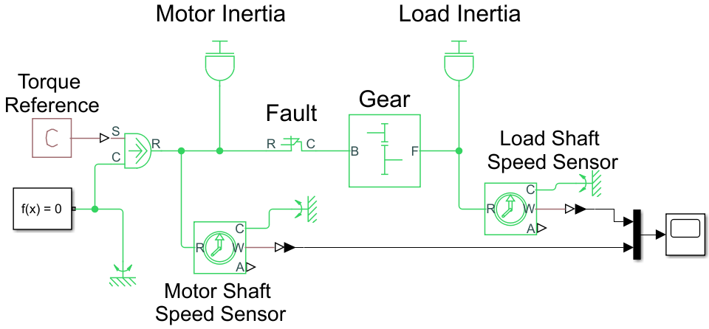

Fig. xx. Gear fault model in Matlab/Simulink environment.
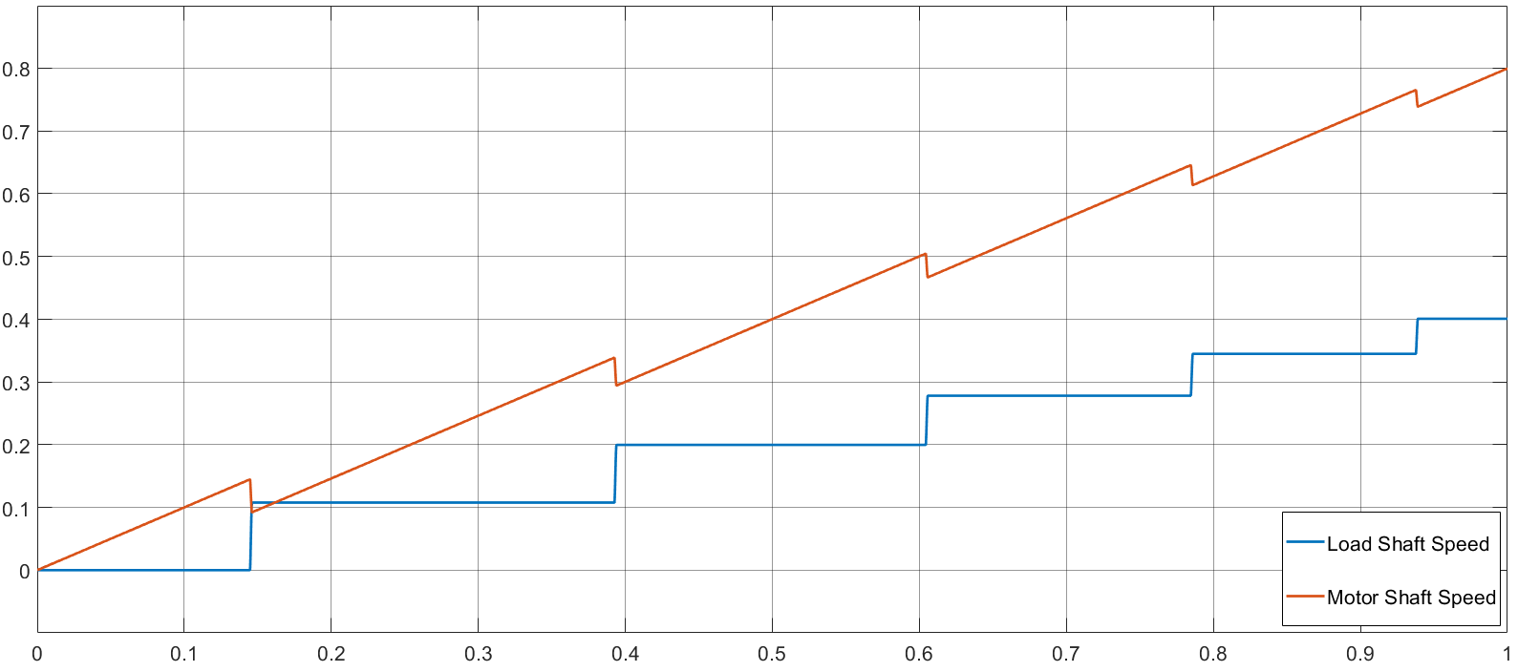

Implementation of the System
If you are

Conclusion

Conclusion
A conclusion section is not required. Although a conclusion may review the main points of the paper, do not replicate the abstract as the conclusion. A conclusion might elaborate on the importance of the work or suggest applications and extensions.

References
- F. N. Author1 and F. N. Author2, “The title of the conference,” in Title of the Proceeding, vol. 3, DOI XX/XXXX/ZZZ.XXXX.XXXXXXX, pp. 1–6, Apr. 2003.
- F. N. Author1, F. N. Author2 and F. N. Author3, “The title of the article,” Other Journal, vol. IA-21, DOI XX/XXXX/ZZZ.XXXX.XXXXXXX, no. 4, pp. 814–821, Mar. 1990.
- F. N. Author1, “The title of the article,” Journal title, vol. 56, DOI XX/XXXX/ZZZ.XXXX.XXXXXXX, no. 2, pp. 581–588, Feb. 2009.
- F. N. Author1, F. N. Author2 and F. N. Author3, “The title of the patent,” Jounal Name, no. 146643245, Oct. 1990.
- F. N. Author, The title of the online book, ser. Example Series. P. Name, Apr. 2003. [Online]. Available: http:// books.google.es
- F. N. Author, Title of the book, 3rd ed., ser. series 1. The address of the publisher: The name of the publisher, vol. 4, ch. 8, pp. 201–213, Apr. 1993, an optional note.

First A. Author1 and the other authors may include biographies at the end of regular papers. The first paragraph may contain a place and/or date of birth (list place, then date). Next, the author’s educational background is listed. The degrees should be listed with type of degree in what field, which institution, city, state or country, and year degree was earned. The author’s major field of study should be lower-cased.
The second paragraph uses the pronoun of the person (he or she) and not the author’s last name. It lists military and work experience, including summer and fellowship jobs. Job titles are capitalized. The current job must have a location; previous positions may be listed without one. Information concerning previous publications may be included.
The third paragraph begins with the author’s title and last name (e.g., Dr. Smith, Prof. Jones, Mr. Kajor, Ms. Hunter). List any memberships in professional societies other than the IEEE. Finally, list any awards and work for IEEE committees and publications. If a photograph is provided, the biography will be indented around it. The photograph is placed at the top left of the biography. Personal hobbies will be deleted from the biography.

Second B. Author2 (M’12) was born in City, Country. He received the M. degree in electrical engineering from University of City, Country in 2012.
The second paragraph uses the pronoun of the person (he or she) and not the author’s last name. It lists military and work experience, including similar information to the previous author, including military, work experience, and other jobs. Job titles are capitalized. The current job must have a location; previous positions may be listed without one. Information concerning previous publications may be included.
The third paragraph begins with the author’s title and last name (e.g., Dr. Smith, Prof. Jones, Mr. Kajor, Ms. Hunter), including similar information to the previous author, including the list of any awards and work for IEEE committees and publications. The photograph is placed at the top left of the biography. Personal hobbies will be deleted from the biography.

Third C. Author3 (M’99–SM’04–F’09) was born in City, Country. He received the M. and SM. and F. degrees in electrical engineering from University of City, Country in 1999, 2004 and 2009 respectively.
The second paragraph uses the pronoun of the person (he or she) and not the author’s last name. It lists military and work experience, including similar information to the previous author, including military, work experience, and other jobs.
The third paragraph begins with the author’s title and last name (e.g., Dr. Smith, Prof. Jones, Mr. Kajor, Ms. Hunter), including similar information to the previous author, including the list of any awards and work for IEEE committees and publications. The photograph is placed at the top left of the biography. Personal hobbies will be deleted from the biography.

Manuscript received Month xx, 2xxx; revised Month xx, xxxx; accepted Month x, xxxx. This work was supported in part by the … Department of xxx under Grant (sponsor and financial support acknowledgment goes here). (Authors’ names and affiliation) F. A. Author1 and S. B. Author2 are with the xxx Department, University of xxx, City, State C.P. Country, on leave from the National Institute for xxx, City, Country (e-mail: author@domain.com). T. C. Author3 is with the National Institute of xxx, City, State C.P. Country (corresponding author to provide phone: xxx-xxx-xxxx; fax: xxx-xxx-xxxx; e-mail: author@ domain.gov).

